Alla G. Vronskaya

Massachusetts Institute of Technology

State Institute for Art Studies, Moscow

**Rationalism** [*Ratsionalizm*] was a modernist movement in Soviet architecture during the 1920s and early 1930s. It was led by architect and prominent architectural pedagogue Nikolai Aleksandrovich LADOVSKII (1881-1941). Alongside CONSTRUCTIVISM, Rationalism comprised two major rivaling approaches to architectural modernism in the USSR. Whereas Ladovskii referred to his method as “rationalist architecture” or “ratio-architecture” [*ratsionalisticheskaiaarkhitektura; ratsio-arkhitektura*], the Constructivists labeled Ladovskii’s school with a derogatory “Formalism.” The word “Rationalism” was introduced by historian Selim Khan-Magomedov in the 1960s as an ethically-neutral pair to Constructivism.

The earliest venues for a development of Rationalist ideas were groups Sinskul’ptarkh (from *Synthesis of sculpture and architecture*) and Zhivskul’ptarkh (from *[The synthesis of] painting, sculpture, architecture*), within which future Rationalists (Ladovskii, Vladimir Krinskii, Vladimir Fidman, AlekseiRuchliadev) collaborated with Cubist sculptor Boris Korolev in 1919-1920. The characteristic Rationalist expressivity of style and a treatment of architectural form as sculpture stemmed from this collaboration. There and within the Group of Objective Analysis at INKhUK (The Institute of Artistic Culture), where he collaborated with Aleksandr RODCHENKO and other future Constructivists, Ladovskii elaborated the cornerstone of his architectural theory: the psychologizing, subjectivist notion of architecture as space, developed on the basis of German formalist aesthetics (Heinrich Wölfflin, Adolf von Hildebrand) and the philosophy of empiriocriticism (Ernst Mach, Richard Avenarius). Space was construed by Ladovskii as a content of one’s mind, a subjective representation of material environment, which depended not on physical laws, but on the laws of sensual perception. Therefore, Ladovskii demonstrated a keen interest in psychological and physiological theories of visual and kinesthetic perception, collaborated with psychologists, and borrowed the methods of experimental psychology to develop the principles of his architectural theory.

In the autumn semester of 1920, Ladovskii succeeded in establishing United Left Studios (*Ob’edinennyelevyemasterskie,* Obmas) within the newly created VKhUTEMAS, where he taught alongside his Rationalist co-thinkers Krinskii and Nikolai Dokuchaev. There, Ladovskii developed his famous sculptural model [*maketnyi*] method of design and his “psycho-analytical” pedagogical method, based on mastering one “element of architecture” after another. The typology of these elements was derived from Mach’s *Analysis of Sensations*, which suggested that reality was perceived as a combination of sounds, shapes, colours, and other elements (properties) of perception. Rationalist pedagogy started with an exploration of geometrical (such as size and shape of an object) and physical (weight, mass, volume, construction) elements, and culminated with an investigation of the rules of their composition, which allowed the construction of complex spatial forms; these rules were based on the dynamics and rhythm of combinations of architectural structures and their elements. Obmas functioned until 1923, after which the so-called Basic Department [*Osnovnoeotdelenie*] was established for teaching introductory courses to new students. Taught and elaborated by the first generation of Ladovskii’sVKhUTEMAS graduates (among them Viktor Balikhin, Sergei Glagolev, Mikhail Korzhev, Ivan Lamtsov, V. Petrov, IuriiSpasskii, and Mikhail Turkus), Rationalist architectural propedeutical (introductory) courses became known as “Space” and, later, “Spatial Group [of Disciplines]” [*Prostranstvennyikontsentr*].

In 1923, the Association of New Architects (ASNOVA) was created to promote Rationalist architecture. Apart fromLadovskii and his VKhUTEMAS colleagues and students, among its members were El LISSITSKY and Konstantin MELNIKOV. Lissitzky was also a co-editor, author and designer of the only issue of *Izvestia ASNOVA* (*ASNOVA’s Newsletter*, 1926)—an attempt at establishing a Rationalist periodical. As common during this period in the USSR, ASNOVA members often entered competitions collectively, as a “brigade.” However, due to their preoccupation with architectural pedagogy and theory, unlike the Constructivists, they obtained few opportunities for realizing their designs. The most important Rationalist commission—the Red Stadium on the Vorob’evy Hills in Moscow—remained unrealized, although the construction began in 1926. An intensification and politicization of architectural discussion during the late 1920s in the situation of a shift towards totalitarianism in politics and towards central planning in the economic life of the country, which preceded the development of “Socialist Realism” as the new unified style of Soviet architecture, led to a series of ardent polemical exchanges between architectural Rationalists and Constructivists in 1927-1928.

In 1927, Ladovskii opened at VKhUTEIN a Psychotechnical Laboratory, which, modeled after Hugo Münsterberg’s psychological laboratory at Harvard, focused on an experimental investigation of spatial perception and on a development of objective criteria for the evaluation of students’ progress and work and of their “architectural talent” (defined as physiological visual capacity) with the help of specially designed machines, such as *prostrometr* (from *prostranstvo*[space] and *metr*, from *izmeriat’* [to measure]), *liglazomer*(from *linia*[line] and *glazomer*[eye-balling]), *ploglazomer* (from *ploskost’* [surface] and *glazomer*) and others.

The same year ASNOVA received a commission for planning a residential complex in the Shabolovka district of Moscow; the challenge was to design an expressive and artistically interesting architectural composition while using standardized construction blocks and an average construction budget. A group led by Nikolai Travin won the internal ASNOVA competition for the project, which was realized in 1927-1928. The still-existing complex was defined by the buildings’ diagonal placement, which was emphasized by a system of views and vistas, and the buildings’ unusual colouration, which did not reflect their tectonics, but rather created novel visual compositions.

Towards the late 1920s, Ladovskii lost interest in the theory of composition and in 1929 founded a second architectural group, ARU, the Association of Architects-Urbanists, devoted exclusively to urban planning. Among its members were Ladovskii’s students and recent graduates, most importantly, GeorgiiKrutikov, VitaliiLavrov, and Viktor Kalmykov. ARU forwarded a conception of urban space as a dynamic form and explored the principles of its design. It treated landscapes and settlements as unified spatial compositions perceived by a moving subject. Among ARU’s projects wasLadovskii’s famous parabolic scheme for the development of the city of Moscow, which improved functionalist zoning by incorporating into the plan a possibility of unlimited growth.

In 1932, with the dissolution of independent architectural organizations, which were now merged into the Union of Soviet architects, Rationalism, alongside other architectural movements, quickly declined. However, Rationalist ideas survived, particularly, within the pedagogical school of the Moscow Architectural Institute (which, alongside other professional institutes, inherited VKhUTEIN); Rationalist compositional theory, for instance, was published as a book (Vladimir Krinskii, Ivan Lamt︠s︡ov, and Mikhail Turkus, *ElementyArkhitekturno-ProstranstvennoiKompozit︠s︡ii*) as late as 1934 and saw a second, revised edition in 1938. In the post-war period, Krinskii, Lamtsov, and Turkus, alongside other former Rationalists, continued to publish and teach architectural composition at the Moscow Architectural Institute.

**Selected References:**

Bliznakov, Milka, “The Rationalist Movement in Soviet Architecture of the 1920s,” *Russian Formalism: A Collection of Articles and Texts in Translation.* Ed. by Stephen Bann and John E. Bowlt.Edinburgh: Scottish Academic Press, 1973*.*

Khan-Magomedov, SelimOmarovich, *Pioneers of Soviet Architecture: The Search for New Solutions in the 1920s and 1930s*, trans. Alexander Lieven; ed. Catherine Cooke. New York, 1987.

Khan-Magomedov, SelimOmarovich, *Ratsionalism (Ratsio-Arkhitektura) “Formalizm.”*Moskva: Arkhitektura-S, 2007.

Khan-Magomedov, SelimOmarovich, *Nikolay Ladovsky.Heroes of Avant-Garde.*Moskva: Sergey E. Gordeev, 2011 [English edition].

Krinskii, V. F., Lamt︠s︡ov, I.V., and Turkus, M.A. *ElementyArkhitekturno-ProstranstvennoiiKompozit︠s︡ii*. Moskva: Gos. nauchno-tekhnicheskoeizd-vostroitel’noiindustriiisudostroenii︠a︡Gosstroizdat NKTP SSSR, 1934.

Senkevitch, Anatole, “Aspects of Spatial Form and Perceptual Psychology in the Doctrine of the Rationalist Movement in Soviet Architecture in the 1920s,” *Via*, No. 6 (1983): 78-115.

**Visual Material:**

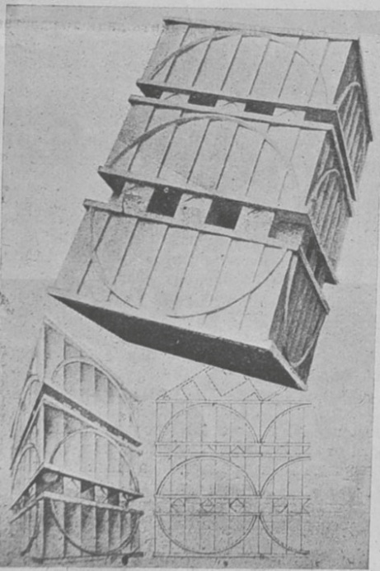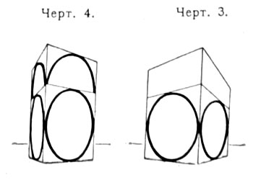

V.A. Petrov. Parallelepiped.Abstract Assignment on Exposure of Form. 1920 [left], and Nikolai Ladovskii, Geometrical analysis of Petrov’s project [right]. Both from *Izvestia ASNOVA*, #1,1926.

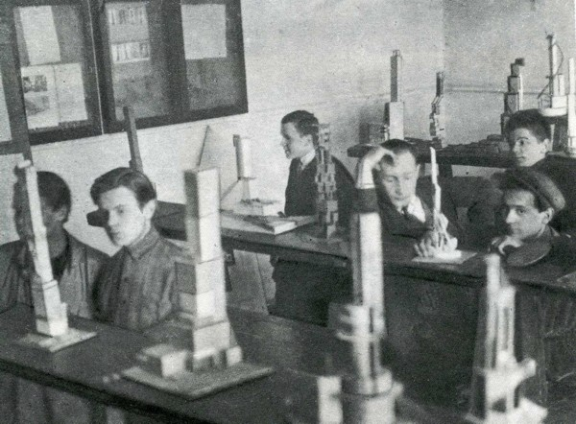

Students of “Space” discipline in front of their works. VKhUTEMAS, 1927.

<http://commons.wikimedia.org/wiki/File:OBMAS.JPG?uselang=ru>

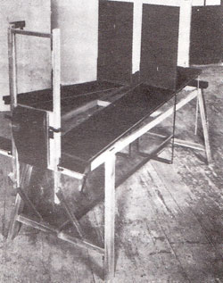

*Prostrometr*, 1928

<http://www.alyoshin.ru/Files/publika/khan_archi/khan_archi_1_066.html>

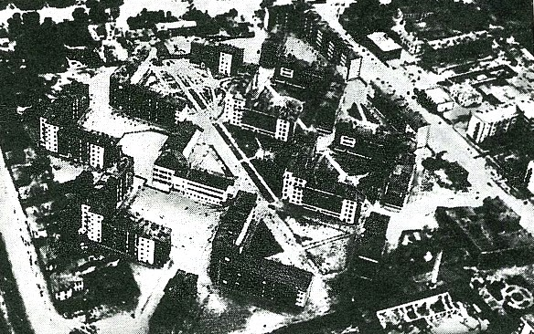

ASNOVA, Shabolovka residential complex, constructed 1927-1928 (aerial view)

http://forum.kinomania.ru/showthread.php?t=11220

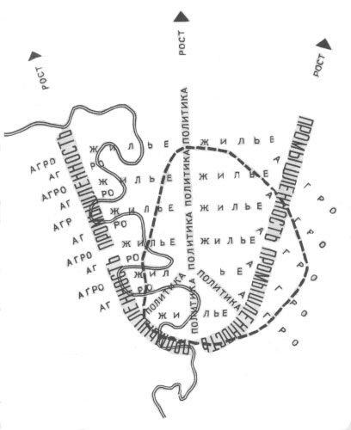

Nikolai Ladovskii, Scheme of a City Growth, 1929-1930

<http://arx.novosibdom.ru/node/2388>